Ronnie Corpuz
CS 499 Milestone Four: Enhancement Three
Databases
Artifact: Grazioso Salvare Dashboard (CS340)
Dr. Sherri Maciosek, Ph.D.
6/3/2026

Artifact Selection Description
I selected the Grazioso Salvare Dashboard from CS 340 Advanced Programming Concepts to be enhanced under Enhancement Three of my CS 499 ePortfolio. The Grazioso Salvare Dashboard was originally designed during my CS 340 coursework before being enhanced for this capstone course. The primary objective of the Grazioso Salvare Dashboard was to provide Grazioso Salvare with a data-driven dashboard that would allow users to review shelter dog records and identify potential candidate dogs for different types of rescue training.
There were two main artifacts included within this project. One is the Jupyter Notebook dashboard file, ProjectTwoDashboard.ipynb, and the second is the Python CRUD module, CRUD_Python_Module.py. Both of these artifacts use various tools such as Dash to present an interactive data table and filtering options. Additionally, Dash is used to display a breed distribution chart and a geolocation map. The CRUD module uses PyMongo to establish a database access layer connecting the dashboard to the MongoDB database. The original database used the aac database and animals collection to retrieve Austin Animal Center shelter outcome data.
Why I Selected the Artifact
I decided to include the Grazioso Salvare Dashboard artifact in my ePortfolio because it demonstrates my ability to develop data-driven applications using reusable backend logic and databases. Since MongoDB was the primary data source and the CRUD module controlled how the dashboard interacted with the database through create, read, update, and delete functions, this artifact fits within the Databases category. Furthermore, the project provides examples of how database information can be presented in usable ways through tables, charts, and maps.
This artifact is significant because it illustrates how database design and implementation relate to real-world decision-making. The dashboard enables users to filter dogs by rescue type, review individual animal records, view breed distribution among shelter dogs, and see animal locations through a map. Because of this, the project represents more than a standard database assignment. It also illustrates how data can support a real organization by allowing users to make better-informed decisions more quickly.
Enhancement Three focused on improving database reliability, error handling, and fallback behavior. Before this enhancement, the original CRUD module contained basic create, read, update, and delete functionality. However, the error handling was very basic. For example, if the local MongoDB credentials or database setup failed, the dashboard could fail or display a blank page. Therefore, I enhanced the CRUD module to improve reliability by including stronger connection handling, safer input validation, more informative error messaging, and a check to confirm that the specified collection is available before attempting database operations.
Additionally, I enhanced the notebook version of the dashboard so that it can continue running even when MongoDB is unavailable. The enhanced dashboard first attempts to retrieve records from MongoDB. If the database connection fails or no records are returned, the dashboard loads the local CSV fallback dataset, aac_shelter_outcomes.csv. This allows the table, chart, and map to remain functional even if the local MongoDB setup, credentials, dataset, or collection are unavailable.
The enhanced version supports the Databases category because it strengthens how the application handles database access and failure conditions. The enhanced version also makes the dashboard more reliable when demonstrating the project. In my development environment, MongoDB authentication failed because the original project was developed during a different course semester and environment. Instead of allowing the dashboard to crash, the enhanced version handled the failure and loaded the CSV fallback data, which successfully displayed the dashboard.
Computer Science Program Outcomes Supported by This Enhancement
This enhancement supports multiple Computer Science program outcomes. The most relevant outcome supported by this enhancement is the ability to apply well-founded techniques, skills, and tools in computing practices to produce computer-based solutions that provide value. I applied various tools, including Python, MongoDB concepts, PyMongo, Dash, Pandas, Plotly, and VS Code, to enhance this project. These tools enabled me to strengthen the database access layer and improve the stability of the dashboard.
This enhancement also supports the outcome related to developing and assessing computing solutions. I evaluated the weaknesses in the original design and determined how to improve it without altering the existing structure of the dashboard. I selected a low-risk strategy by enhancing the CRUD module and implementing fallback data loading instead of redesigning the entire project. This allowed the dashboard to maintain its original form while becoming more reliable.
Finally, this enhancement supports the security mindset outcome. While this project is not a security application, database authentication failure is an important issue that must be handled safely. The enhanced version of the CRUD module provides more explicit connection messages and avoids uncontrolled crashes when credentials, collection access, or database availability fail. This improves safety and reduces confusion when errors occur while attempting to use the application.
At this point, I am not required to revise my original outcome coverage plan. Enhancement One focused on software design and engineering through the Travlr Getaways project. Enhancement Two focused on algorithms and data structures through the Contact Service project. Enhancement Three now focuses on databases through the Grazioso Salvare Dashboard project.
Reflection on the Enhancement Experience
Through enhancing this artifact, I gained a better appreciation for error handling mechanisms associated with databases and planning for fallback scenarios. Initially, I no longer had access to the original Jupyter environment that I used during CS 340. Once I established a new environment using VS Code, I had to troubleshoot several compatibility issues before I was able to successfully run the dashboard.
Two major challenges occurred during my experience with this project. The first challenge was that older versions of JupyterDash were used within the original notebook. Newer versions of Dash used within VS Code did not support the older JupyterDash setup in the same way. Because of this, I modified the notebook to use Dash directly instead of JupyterDash and revised the run command so that the dashboard opens externally in a browser. This allowed me to load and access the dashboard locally through a URL link and verify that the interface continued to load properly.
A second major challenge was related to my inability to authenticate with MongoDB on my local machine. Because the project was originally developed in a different course environment, my local machine did not have the same MongoDB setup, credentials, database, or collection. Rather than rebuild an entirely new database setup on my local machine, I added safety measures into the project so that it would continue to operate when database connection or authentication failures occur. Specifically, after modifying the CRUD module, it now notifies users of database connection problems and prevents the application from crashing when collections are unavailable.
By incorporating CSV fallback loading into the project, I ensured that even though MongoDB could not be accessed locally, the dashboard can still display data, charts, and maps. This is beneficial because it provides greater reliability and stability when demonstrating the project.
As previously mentioned, enhancing this artifact reinforced the connection between database programming and practical software development. Database programming does not only involve creating and accessing stored records. It also involves validation, error checking, clear messages, and recovery options for handling problems that arise in database-driven applications.
Overall, the modifications made through this database enhancement increased the reliability and safety of the project. The enhanced dashboard now handles database access failure more effectively and still provides a functional user interface when fallback data is available.

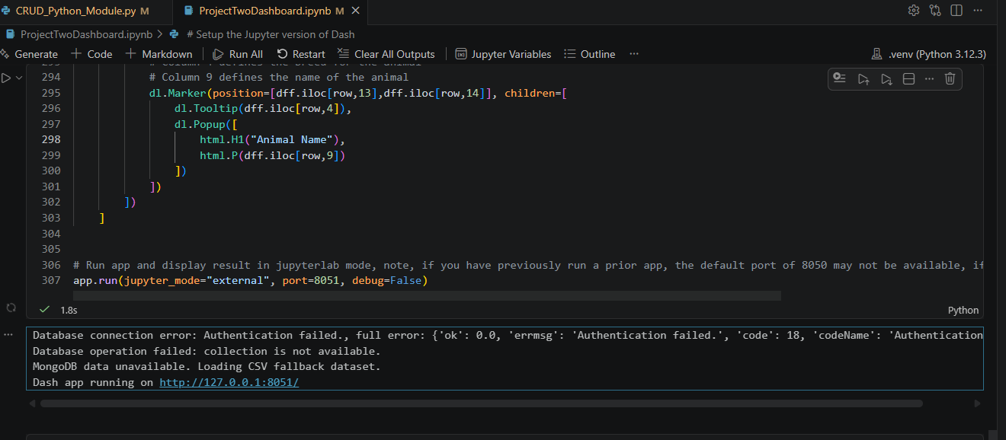
Figure 1. Enhanced database handling in VS Code showing MongoDB authentication failure, collection unavailable, CSV fallback loading, and successful Dash app launch.
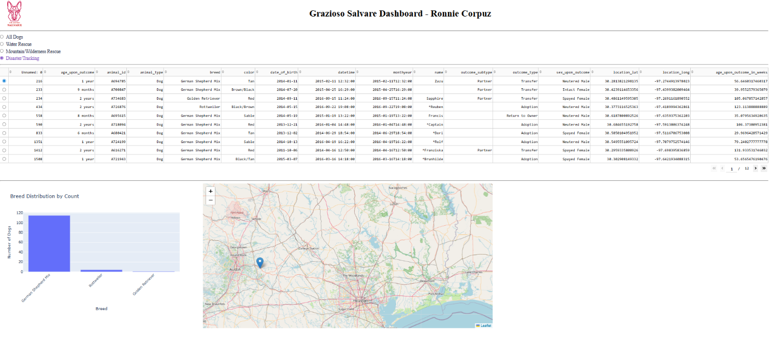
Figure 2. Enhanced Grazioso Salvare Dashboard running in the browser with table data, a breed distribution chart, and a geolocation map using the fallback dataset.

AI Usage Acknowledgment
I used AI to help troubleshoot VS Code and Jupyter setup steps, identify safe code changes, and improve the wording of this narrative.

